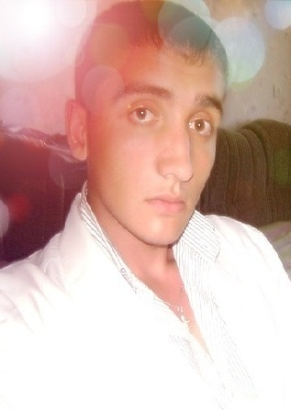

**Khlestkin Viktor**

**23 years old (5 of November 1989) Male, Kazakhstan, Rudny, ready to relocate (Ulyanovsk, Russia) Ready for business trips**

**________________________________________**

**+7 777 3039997 preferred contact**

**Khlyostkin@yahoo.com**

**________________________________________**

**Desired position and salary**

**Paramedic**

**Healthcare / Pharmacy**

**• Medical representative**

**• Medical equipment**

**• Medical drugs**

**Full-time, Full time schedule**

**Education**

**Kazakhstan, 2009 Medical College "Zhardem"**

**General Medicine, Specialty "assistant general practice," red diploma**

**The license for medical practice, internal medicine, emergency conditions**

**Languages**

**Russian - native**

**English - basic knowledge**

**German - basic knowledge**

**Additional education**

**2010 Kostanay drug abuse clinic, "Criteria for diagnosis and drug and alcohol"**

**Experience 2 years 6 months**

**November 2011 - till now (1 year 10 months)**

**TOO "Kazanada" (Astana, www.kazanada.kz)**

**Paramedic**

**Vaccination**

**Industry physicals**

**Medical consultation**

**Pre-trip and pre-shift inspection**

**Urgent / emergency care**

**Occupational health**

**Car accident and emergency**

**Testing for the presence of alcohol and drugs**

**Issuance sheets disability**

**Independent health and medical audit**

**Consultation 24 hours a day, 7 days a week**

**Coordination and support in the event of hospitalization**

**Outpatient treatment**

**Industrial Hygiene Services**

**Provision of monthly medical reports and recommendations for the prevention of diseases**

**Training of employees of enterprises**

**September 2009 - April 2010 (8 months)**

**TOO LOTS "Sunrise" (Kostanay) - Medical / Pharma**

**Paramedic health post**

**Provision of emergency, emergency medical care**

**Outpatient care of patients**

**Medical records, vaccination of employees**

**Skills**

**Kompetentnost, literacy, right speech, speak clearly, responsibility, analytical skills, creativity, communication skills, accuracy, high trainability**

**Citizenship, travel time to work**

**Citizenship: Russia, Kazakhstan**

**Work permit: Russia, Kazakhstan**

**Travel time: any**